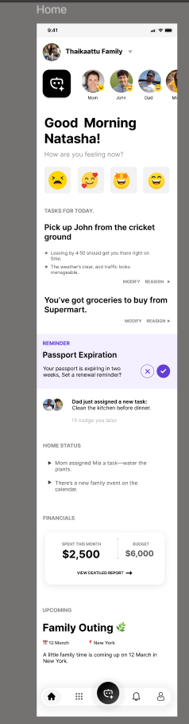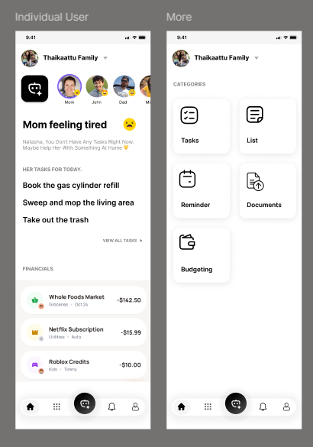

1) Overall App Structure

Core Concept
The app is a Family Workspace with two layers of data everywhere:
Personal layer (only me)
Family-shared layer (visible to family based on what I choose to share)
This rule applies across Tasks, Lists, Calendar/Reminders, Documents, Expenses/Budgeting.

Navigation (Footer)
Bottom navigation is fixed and global (same on every screen):
Home (AI-driven dashboard)
Grid/Modules (or “More”) (your screenshot shows this as a separate tab page)
AI Chat / Assistant (center FAB-style icon)
Notifications
Profile / Settings
Key point: AI is not just a chatbot page. AI is integrated into the dashboard content and available as a dedicated assistant entry point from the footer center button.

2) Header Layout (Top Area)

Header is consistent across major screens:
Family selector dropdown (ex: “Thaikaattu Family”)
Optional: search / notifications (depending on screen)
Under the header: horizontal family member avatars (Mom, John, Dad, etc.)
This member strip is a context switcher:
Clicking a member opens that member’s “Individual view” dashboard.
This does not mean you’re impersonating them—this is “view their shared snapshot”.

3) Home Screen (Dashboard / Flash Screen)
This screen is split into two major zones:

A) AI-Driven Dynamic Zone (Top Section)
From “Good Morning Natasha” down to the “Dad just assigned a new task…” card:
➡️ this entire area is AI-curated and personalized.

What AI does here
AI generates and updates:
Greeting + mood prompt (“How are you feeling now?”)
Context cards (tasks, reminders, suggestions)
Nudges (based on deadlines, patterns, usage, location later)
Family feed snippets (latest important change across shared space)

Mood input → AI output loop
User taps an emoji (“tired”, “happy”, etc.)
AI uses that as a signal to:
adjust recommendations
highlight urgent tasks only
reduce cognitive load (fewer cards, simpler suggestions)
optionally suggest “delegate” actions (“Ask Dad to handle pickup?”

Dynamic cards you already described
Examples of cards AI will show:
“Pick up John from the cricket ground”
“You’ve got groceries to buy from Supermart”
Reminders like passport expiry
“Dad assigned a new task: Clean kitchen before dinner”
Each card supports actions like:
Modify
Reassign
Snooze
Mark done
Ask AI to reschedule / rewrite / break into subtasks
So the dashboard is not static widgets, it’s an AI-driven decision layer that pulls from all modules.

B) Structured Modules Zone (Lower Section)
After the AI zone ends, the rest is more “standard” widgets like:
Financials (Spent this month vs budget + view report)
Home Status (small summary bullets)
Upcoming (next family event card)
These are still influenced by AI optionally (summaries, highlights), but the layout is stable and predictable.

4) Individual Member View (Example: Mom View)
When you tap “Mom” from the avatar strip, you open a screen like your second screenshot:

Purpose
Show a filtered view of Mom’s shared state:
Her mood status (“Mom feeling tired 😓”)
Her tasks for today (the ones relevant to her)
Her financial activity (her spending entries if she shares them OR only what she controls visibility for)

Data Rule (Important)
Mom has:
Personal tasks (only she sees)
Shared tasks (family can see)
This screen shows:
Mom’s shared tasks + optionally “summary count” of personal tasks if allowed (depending on role permissions, like parent/admin vs child)

CTA / Expansion
“View all tasks” goes deeper into task module filtered to Mom context:
Personal tasks (Mom only)
Shared tasks (Family-visible)

5) More Screen (Modules Grid)
This is your “More” screenshot with category tiles:
Tasks
List
Reminder (Calendar)
Documents
Budgeting

Why this screen exists
It’s the structured entry point for users who don’t want AI and want direct module access.

6) Module Behavior: Personal vs Family (Universal Pattern)
Every module has the same visibility structure:

Default Views inside module
Top toggle (or segmented control):
Personal
Family
So every feature you build must support:
creating items as personal by default
sharing selected items with family
controlling who can view/edit (role-based)

Examples
Tasks
Personal tasks
Family tasks
Share a personal task → becomes visible to family (or specific members)
Lists
Personal lists (my grocery list)
Shared lists (family grocery list)
Calendar / Reminder
Personal calendar
Family calendar
Events have visibility setting at creation:
personal / family / specific member(s)
Documents
Personal vault documents
Shared documents folder
Budgeting
Personal expenses
Family expenses / shared budgets
Visibility controls define what others see (summary vs full detail depending on role)

7) Calendar / Reminder Flow (As you described)

Entry points
From More → Reminder
From the AI dashboard cards (tap reminder card)
From AI Chat (voice/text: “Add event tomorrow 5pm”)

Calendar has two calendars
Personal calendar
Family calendar
With filters:
show both merged
show only one
show by member

Must support your previously defined scheduling features
event create/edit/delete
recurring
conflict detection (family-aware)
attendee selection (family members)
views: day/week/month/agenda
quick add
AI-assisted scheduling (“who is free at 5?”)

8) AI Chat / Assistant (Center Footer Button)

This is the “control layer” for the entire app
The assistant can:
read relevant context (depending on permission)
create actions inside any module
modify items (reschedule, reassign, split tasks, summarize)

AI integration modes
Passive AI on Home Dashboard
produces cards automatically
Interactive AI in Chat
user asks → AI executes actions
Inline AI inside modules
“AI” button to rewrite, summarize, create subtasks, suggest schedule, categorize expense, etc.
So AI is not only “content”. It’s actions + automation.

9) Theme + Visual System (Based on Screenshot Style)

Layout style
Clean, minimal, card-based
Lots of whitespace
Rounded cards
Soft shadows
Friendly avatars + emojis
Typography heavy (big greeting + clear section headers

Interaction style
“Glanceable” first (dashboard)
“Tap to drill down” second (modules)
Most actions available in ≤2 taps
Sticky bottom nav for thumb reach

10) Why this description helps your library selection
Because your UI requires:
Highly customizable card-based dashboard
Horizontal member switcher
Segmented personal/family toggles everywhere
Calendar with multiple views + filters + conflict detection
Real-time syncing + shared state updates
AI chat entry + AI inline actions
So when you shortlist libraries, you must check:
how deeply you can customize UI components (cards, gestures, tabs)
how good the calendar library is in RN
performance with long lists and real-time updates
state management + offline support approach

